

**Lab 10.1.2.5 - Configure CDP and LLDP**

## Topology

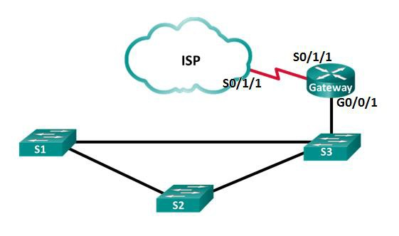

**Addressing Table**

|  |  |  |  |
| --- | --- | --- | --- |
| **Device** | **Interface** | **IP Address** | **Subnet Mask** |
| **Gateway** | **G0/0/1** | 192.168.1.254 | 255.255.255.0 |
|  | **S0/1/1** | 209.165.200.226 | 255.255.255.252 |
| **ISP** | **S0/1/1 (DCE)** | 209.165.200.225 | 255.255.255.252 |

**Objectives**

#### Part 1: Build the Network and Configure Basic Device Settings Part 2: Network Discovery with CDP

**Part 3: Network Discovery with LLDP**

**Background / Scenario**

**Cisco Discovery Protocol (CDP)** is a Cisco proprietary protocol for network discovery on the data link layer. It can share information such as device names and IOS versions, with other physically connected Cisco devices. **Link Layer Discovery Protocol (LLDP)** is vendor-neutral protocol using on the data link layer for network discovery. It is mainly used with network devices in the local area network (LAN). The network devices advertise information, such as their identities and capabilities to their neighbors.

In this lab, you must document the ports that are connected to other switches using CDP and LLDP. You will document your findings in a network topology diagram. You will also enable or disable these discovery protocols as necessary.

# Part 1: Build the Network and Configure Basic Device Settings

In Part 1, you will set up the network topology and configure basic settings on the router and switches.

### Step 1: Configure basic device settings for the switches

* + 1. Console into the device and enable privileged EXEC mode.
    2. Enter configuration mode.
    3. Disable DNS lookup to prevent the switch from attempting to translate incorrectly entered commands as though they were host names.
    4. Configure the hostname according to the topology.

**Step 2: Configure basic device settings for the routers**

* + 1. Console into the device and enable privileged EXEC mode.
    2. Enter configuration mode.
    3. Copy and paste the following configurations into the routers.

**ISP:**

hostname ISP

no ip domain lookup

interface Serial0/1/1

ip address 209.165.200.225 255.255.255.252

no shutdown

**Gateway:**

hostname Gateway

no ip domain lookup

interface GigabitEthernet0/0/1

ip address 192.168.1.254 255.255.255.0

ip nat inside

no shutdown

interface Serial0/1/1

ip address 209.165.200.226 255.255.255.252

ip nat outside

no shutdown

ip nat inside source list 1 interface Serial0/1/1 overload

access-list 1 permit 192.168.1.0 0.0.0.255

**Part 2: Network Discovery with CDP**

On Cisco devices, **CDP** is enabled by default. You will use CDP to discover the ports that are currently connected.

a. On router Gateway, enter the **show cdp** command in the privileged EXEC mode to verify that CDP is currently enabled on router Gateway.

Gateway# **show cdp** Global CDP information:

Sending CDP packets every 60 seconds Sending a holdtime value of 180 seconds Sending CDPv2 advertisements is enabled

How often are CDP packets sent?___________________

If CDP is disabled on Gateway, enable CDP by issuing the **cdp run** command in the global configuration mode.

Gateway(config)# **cdp run**

Gateway(config)# **end**

b. Issue the **show cdp interface** to list the interfaces that are participating in CDP advertisements.

Gateway# **show cdp interface**

Vlan1 is administratively down, line protocol is down

Sending CDP packets every 60 seconds

Holdtime is 180 seconds

GigabitEthernet0/0/0 is administratively down, line protocol is down

Sending CDP packets every 60 seconds

Holdtime is 180 seconds

GigabitEthernet0/0/1 is up, line protocol is up

Sending CDP packets every 60 seconds

Holdtime is 180 seconds

Serial0/1/0 is administratively down, line protocol is down

Sending CDP packets every 60 seconds

Holdtime is 180 seconds

Serial0/1/1 is up, line protocol is up

Sending CDP packets every 60 seconds

Holdtime is 180 seconds

How many interfaces are participating in the CDP advertisement? ________________

Which interfaces are up?_________________

c. Issue the **show cdp neighbors** command to determine the CDP neighbors.

Capability Codes: R - Router, T - Trans Bridge, B - Source Route Bridge

S - Switch, H - Host, I - IGMP, r - Repeater, P - Phone

Device ID Local Intrfce Holdtme Capability Platform Port ID

Switch Gig 0/0/1 177 S 2960 Gig 0/1

ISP Ser 0/1/1 177 R ISR4300 Ser 0/1/1

d. For more details on CDP neighbors, issue the **show cdp neighbors detail** command.

Gateway# **show cdp neighbors detail**

Device ID: Switch

Entry address(es):

Platform: cisco 2960, Capabilities: Switch

Interface: GigabitEthernet0/0/1, Port ID (outgoing port): GigabitEthernet0/1

Holdtime: 165

Version :

Cisco IOS Software, C2960 Software (C2960-LANBASE-M), Version 12.2(25)FX, RELEASE SOFTWARE (fc1)

Copyright (c) 1986-2005 by Cisco Systems, Inc.

Compiled Wed 12-Oct-05 22:05 by pt_team

advertisement version: 2

Duplex: full

---------------------------

Device ID: ISP

Entry address(es):

IP address : 209.165.200.225

Platform: cisco ISR4300, Capabilities: Router

Interface: Serial0/1/1, Port ID (outgoing port): Serial0/1/1

Holdtime: 165

Version :

Cisco IOS XE Software, Version 03.13.04.S - Extended Support Release

Cisco IOS Software, ISR Software (X86_64_LINUX_IOSD-UNIVERSALK9-M), Version 15.5(3)S5, RELEASE SOFTWARE (fc2)

Technical Support: http://www.cisco.com/techsupport

Copyright (c) 1986-2017 by Cisco Systems, Inc.

Compiled Mon 05-Oct-15 11:24 by mcpre

advertisement version: 2

Duplex: full

* + 1. What can you learn about **ISP** and **S3** from the outputs of the **show cdp neighbors detail** command?

____________________________________________________________________________________

____________________________________________________________________________________

* + 1. Configure the **SVI** on **S3**. Use an available IP address in **192.168.1.0 / 24** network. Configure **192.168.1.254** as the default gateway.

S3(config)# **interface vlan 1**

S3(config-if)# **ip address 192.168.1.3 255.255.255.0**

S3(config-if)# **no shutdown**

S3(config-if)# **exit**

S3(config)# **ip default-gateway 192.168.1.254**

* + 1. Issue the **show cdp neighbors detail** command on **Gateway**. What additional information is available?

____________________________________________________________________________________

* + 1. For security reasons, it is a good idea to **turn off** CDP on an interface facing an external network. Issue the **no cdp enable** in the interface configuration mode on the **S0/1/1** interface on **Gateway**.

Gateway(config)# **interface s0/1/1**

Gateway(config-if)# **no cdp enable**

Gateway(config-if)# **end**

To verify that CDP has been turned off on the interface S0/0/1, issue the **show cdp neighbors** or **show cdp interface** command. You may need to wait for the hold time to expire. The hold time is the amount of time the network devices will hold the CDP packets until the devices discard them.

Gateway# **show cdp neighbors**

Capability Codes: R - Router, T - Trans Bridge, B - Source Route Bridge

S - Switch, H - Host, I - IGMP, r - Repeater, P - Phone

Device ID Local Intrfce Holdtme Capability Platform Port ID

S3 Gig 0/0/1 126 S 2960 Gig 0/1

The interface **S0/1/1** on **Gateway** no longer has a CDP adjacency with the ISP router. But it still has CDP adjacencies with other interfaces.

Gateway# **show cdp interface**

Vlan1 is administratively down, line protocol is down

Sending CDP packets every 60 seconds

Holdtime is 180 seconds

GigabitEthernet0/0/0 is administratively down, line protocol is down

Sending CDP packets every 60 seconds

Holdtime is 180 seconds

GigabitEthernet0/0/1 is up, line protocol is up

Sending CDP packets every 60 seconds

Holdtime is 180 seconds

Serial0/1/0 is administratively down, line protocol is down

Sending CDP packets every 60 seconds

Holdtime is 180 seconds

Serial0/1/1 is up, line protocol is up **(SIGUE APARECIENDO)**

Sending CDP packets every 60 seconds

Holdtime is 180 seconds

How many interfaces are CDP enabled? _________

Which interfaces are CDP disabled? ________

* + 1. To disable CDP globally, issue the **no cdp run** command in the global configuration mode.

Gateway# **conf t**

Gateway(config)# **no cdp run**

Gateway(config)# **end**

Which command(s) would you use to verify that CDP has been disabled?

____________________________________________________________________________________

* + 1. Enable CDP globally on Gateway.

Gateway# **conf t**

Gateway(config)# **cdp run**

Gateway(config)# **end**

* + 1. Console into all the switches and use the CDP commands to determine the Ethernet ports that connected to other devices. An example of the CDP commands for **S3** is displayed below.

S3# **show cdp neighbors**

Capability Codes: R - Router, T - Trans Bridge, B - Source Route Bridge

S - Switch, H - Host, I - IGMP, r - Repeater, P - Phone

Device ID Local Intrfce Holdtme Capability Platform Port ID

S1 Gig 0/2 131 S 2960 Gig 0/1

S2 Fas 0/24 131 S 2960 Fas 0/24

Gateway Gig 0/1 140 R ISR4300 Gig 0/0/1

# Part 3: Network Discovery with LLDP

On Cisco devices, LLDP maybe enabled by default. You will use LLDP to discover the ports that are currently connected.

* + 1. On Gateway, enter the **show lldp** command in the privileged EXEC mode.

Gateway# **show lldp**

Global LLDP Information:

Status: ACTIVE

LLDP advertisements are sent every 30 seconds

LLDP hold time advertised is 120 seconds

LLDP interface reinitialisation delay is 2 seconds

If LLDP is disabled, enter the **lldp run** command in the global configuration mode.

Gateway(config)# **lldp run**

Issue the **show lldp neighbors** command. Which devices are neighbors to Gateway?

____________________________________________________________________________________

Gateway# **show lldp neighbors**

Capability codes:

(R) Router, (B) Bridge, (T) Telephone, (C) DOCSIS Cable Device

(W) WLAN Access Point, (P) Repeater, (S) Station, (O) Other

Device ID Local Intf Hold-time Capability Port ID

S3 Gig0/0/1 120 B Gig0/1

Total entries displayed: 1

If there are no LLDP neighbors for Gateway, enable LLDP on the switches. Issue **lldp run** in the global configuration mode on the devices.

S1(config)# **lldp run**

S2(config)# **lldp run**

S3(config)# **lldp run**

* + 1. Issue the **show lldp neighbors detail** command on Gateway.

Gateway# **show lldp neighbors detail**

------------------------------------------------

Chassis id: 0030.F252.D419

Port id: Gig0/1

Port Description: GigabitEthernet0/1

System Name: S3

System Description:

Cisco IOS Software, C2960 Software (C2960-LANBASE-M), Version 12.2(25)FX, RELEASE SOFTWARE (fc1)

Copyright (c) 1986-2005 by Cisco Systems, Inc.

Compiled Wed 12-Oct-05 22:05 by pt_team

Time remaining: 90 seconds

System Capabilities: B

Enabled Capabilities: B

Management Addresses - not advertised

Auto Negotiation - supported, enabled

Physical media capabilities:

100baseT(HD)

100baseT(FD)

1000baseT(FD)

Media Attachment Unit type: 10

Vlan ID: 1

Total entries displayed: 1

What port is used on S3 to connect to the Gateway router?

____________________________________________________________________________________

* + 1. Use the **show** command outputs from **CDP** to document the connected ports in the network topology.

Gateway# **show cdp neighbors**

S1# **show cdp neighbors**

S2# **show cdp neighbors**

S3# **show cdp neighbors**

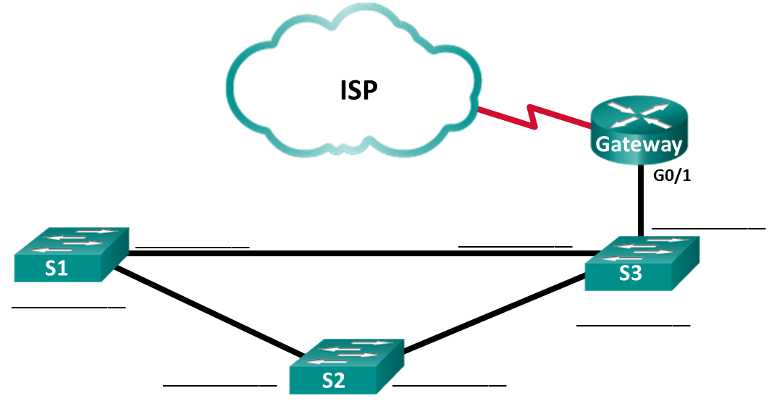

1. Reflection

Within a network, on which interfaces should you not use discovery protocols? Explain.

_______________________________________________________________________________________

_______________________________________________________________________________________

_______________________________________________________________________________________

_______________________________________________________________________________________